# Prerequisites Task Information

## Passwords Index

|  |  |  |
| --- | --- | --- |
| Password Group | Login Name | Password |
| Operation System | root | “rootadmin” |
|  | oracle | “oracleadmin” |
|  |  |  |
| Oracle System | sys | “sysadmin” |
|  | system | “sysadmin” |
|  |  |  |
| Oracle Users | All DB users | “%PWD%” |
|  |  |  |
|  |  |  |

## Folder Paths Index

|  |  |  |
| --- | --- | --- |
| Path Group | Path Description | Path |
| Operation System | Oracle RDBMS – BIN | /oracle/app/oracle |
|  | Oracle Inventory | /oracle/app/oraInventory |
|  | Oracle Database Storage | /oracle/oradata |
|  | Oracle Install Directory | /oracle/install |
| Oracle | ORACLE_BASE | /oracle/app/oracle |
|  | ORACLE_HOME | $ORACLE_BASE/product/11.2 |
|  |  |  |
| FTP | ftp Incoming Folder | **/ftp/incoming** |
|  |  |  |
|  |  |  |

# Oracle Architecture - Partitioning

## Task 01: CREATE Example of Range partitioning

**The Main Task** is to creating example of range partitioning table. Perform Administration tasks on all partitioning types:

| **Maintenance Operation** | **Range Composite Range-\*** | **Interval Composite Interval-\*** | **Hash** | **List Composite List-\*** | **Reference** |
| --- | --- | --- | --- | --- | --- |
| [Adding Partitions](http://docs.oracle.com/cd/B28359_01/server.111/b32024/part_admin.htm#i1007318) | ADD PARTITION | ADD PARTITION | ADD PARTITION | ADD PARTITION | N/A[Foot 1](http://docs.oracle.com/cd/B28359_01/server.111/b32024/part_admin.htm" \l "BAJCBJBA) |
| [Coalescing Partitions](http://docs.oracle.com/cd/B28359_01/server.111/b32024/part_admin.htm#i1007442) | N/A | N/A | COALESCE PARTITION | N/A | N/A[Footref 1](http://docs.oracle.com/cd/B28359_01/server.111/b32024/part_admin.htm" \l "sthref213) |
| [Dropping Partitions](http://docs.oracle.com/cd/B28359_01/server.111/b32024/part_admin.htm#i1007479) | DROP PARTITION | DROP PARTITION | N/A | DROP PARTITION | N/A[Footref 1](http://docs.oracle.com/cd/B28359_01/server.111/b32024/part_admin.htm" \l "sthref214) |
| [Merging Partitions](http://docs.oracle.com/cd/B28359_01/server.111/b32024/part_admin.htm#i1007638) | MERGE PARTITIONS | MERGE PARTITIONS | N/A | MERGE PARTITIONS | N/A[Footref 1](http://docs.oracle.com/cd/B28359_01/server.111/b32024/part_admin.htm" \l "sthref215) |
| [Moving Partitions](http://docs.oracle.com/cd/B28359_01/server.111/b32024/part_admin.htm#i1007920) | MOVE PARTITION | MOVE PARTITION | MOVE PARTITION | MOVE PARTITION | MOVE PARTITION |
| [Splitting Partitions](http://docs.oracle.com/cd/B28359_01/server.111/b32024/part_admin.htm#i1008028) | SPLIT PARTITION | SPLIT PARTITION | N/A | SPLIT PARTITION | N/A[Footref 1](http://docs.oracle.com/cd/B28359_01/server.111/b32024/part_admin.htm" \l "sthref216) |
| [Truncating Partitions](http://docs.oracle.com/cd/B28359_01/server.111/b32024/part_admin.htm#i1008226) | TRUNCATE PARTITION | TRUNCATE PARTITION | TRUNCATE PARTITION | TRUNCATE PARTITION | TRUNCATE PARTITION |

**Task Results:**

**Range**

**Create table with partitions Range**

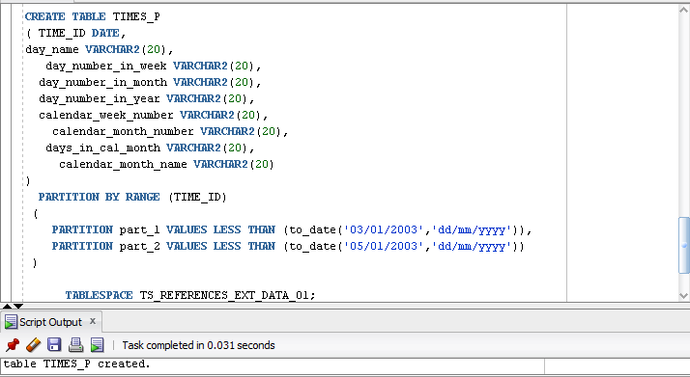

**Merge Partitions**

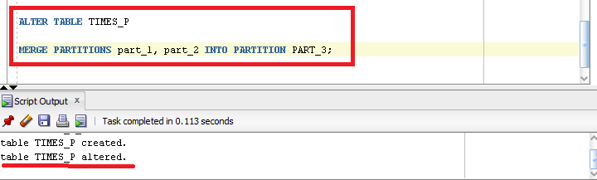

**Move partition to another tablespace.**

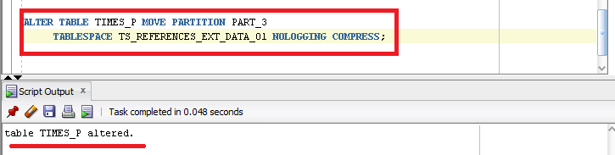

**Splitting**

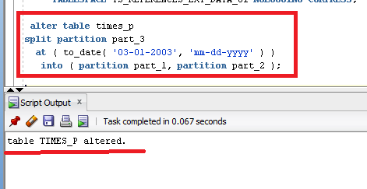

**Truncating the partition**

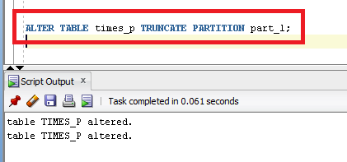

**List**

**The table was dropped and created again**

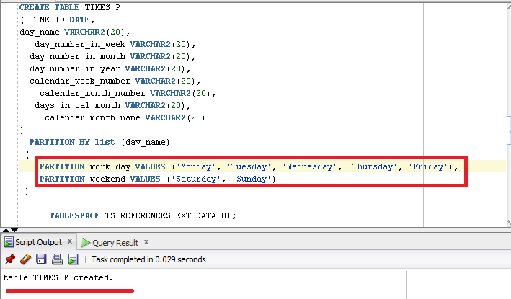

**Select by partition**

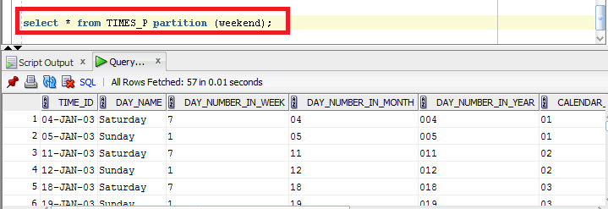

**Merge**

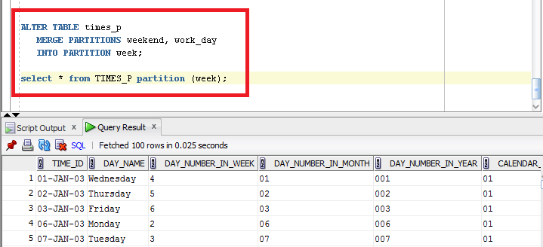

**Split**

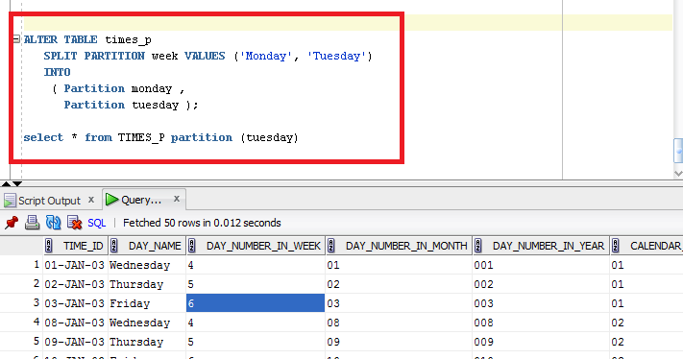

**Hash**

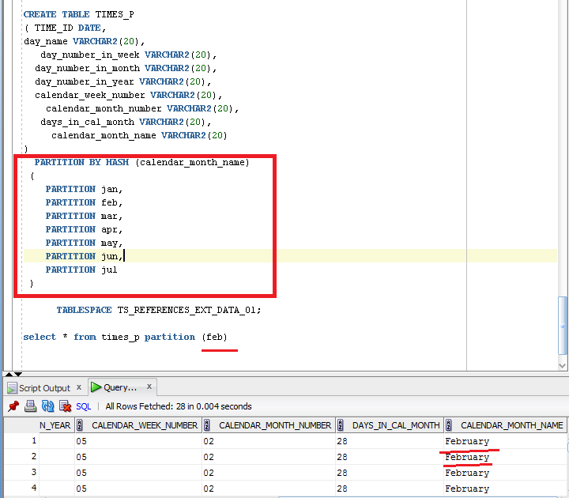

**Coalescing**

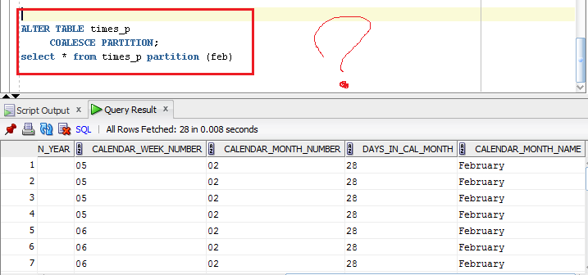

Create document that will store all screenshot about **Maintenance Operations;**

# Business Task - Partitioning Facts

## Task 02: Partitioning Facts

**The Main Task** is to partitioning Fact table that you create and describe on yours Solution Concept

Default partitioning scheme:

* Range by Even_dt (Daily, Monthly …)
* Hash by one of IDs (4 Subpartitions)

**PARTITIONING**

The query execution speed, which works with fact table, can be increased with partitioning.

As business plan of the star is to show quickly the information about sales by channels and in section of time, so the composite partitioning should be done.

It will be used partitioning by quarters and every quarter will be partitioned by channels of sales.

Range Partition by EVENT_ID. The sales are divided by quarters.

|  |  |  |
| --- | --- | --- |
| Quarter, number | Start date, dd/mm | End date, dd/mm |
| 1 | 01/01 | 31/03 |
| 2 | 01/04 | 30/06 |
| 3 | 01/07 | 30/09 |
| 4 | 01/10 | 31/12 |

Hash partition of every quarter by channels. Number of sub partitions is 4, because it should be the degree of 2 and because we have 6 channels.

The result table

|  |  |  |  |
| --- | --- | --- | --- |
| Sales | Quarter 1 | Hash_1 | facts |
| facts |
| facts |
| … |
| Hash_2 | …. |
| Hash_3 |  |
| Hash_4 |  |
| Quarter 2 | Hash_1 |  |
| Hash_2 |  |
| Hash_3 |  |
| Hash_4 |  |
| Quarter 3 | Hash_1 |  |
| Hash_2 |  |
| Hash_3 |  |
| Hash_4 |  |
| Quarter 4 | Hash_1 |  |
| Hash_2 |  |
| Hash_3 |  |
| Hash_4 |  |

**Task Results:**

* Add chapter to Solution Concept describing Partitioning rules on Fact Tables.
* Change Creation Script for Fact Table.

Script is saved into txt file.